Urgent Clinical Genetics Referrals – Clinical users

Placing referral orders (3 ways):
- From an outpatient encounter- you have an ‘add order’ button (bottom left of the screen) that allows you to type and search for your referrals

- From an inpatient workspace – you can use your orders tab and select the ‘future outpatient’ option
- Alternatively, you can create an ‘orders only’ encounter by clicking Epic> Patient Care> encounter> select your patient> +create an Encounter> Orders only. You have an ‘add order’ button (bottom left of the screen) that allows you to type and search for your referrals
Available referrals:
To find the clinical genetics referral options you can search ‘referral clinical genetics’ and it will load all available options. To ensure you can see the full up to date list of referrals, please ensure you are on the facility list tab as shown in the screenshot:
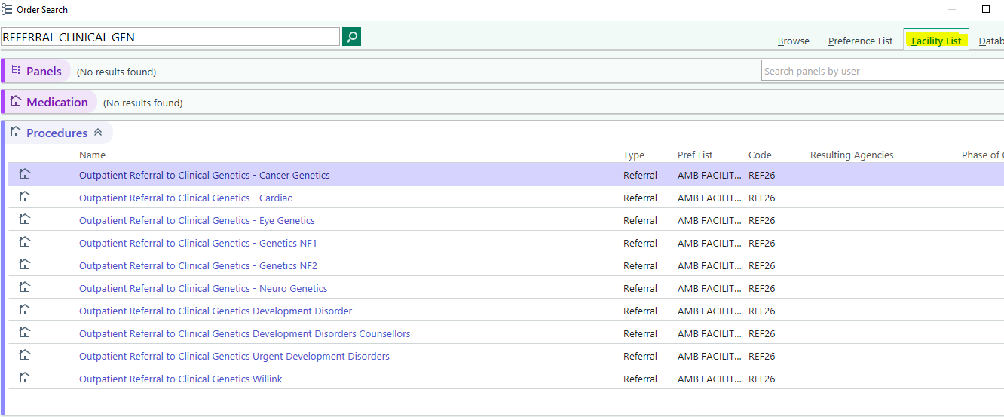
All Urgent referrals

After selecting your chosen referral type, the below order form should open up on your screen and you will be required to complete all necessary information:
*please note, urgent ward referrals (E.g., NICU and PICU) do not need to complete additional pregnancy fields if not applicable for the referral.
**See end of document for further guidance on reasons for referral
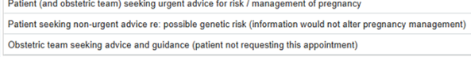
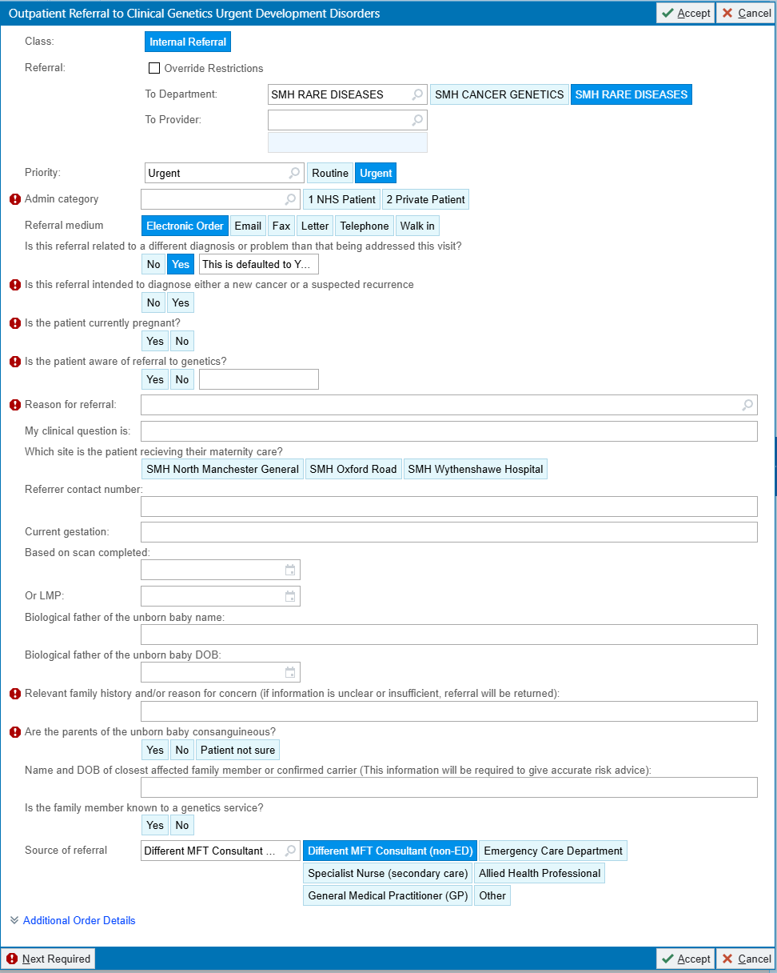
Select cancer or rare disease
(for anything noncancer)
For urgent ward referrals – please select option 1 ‘seeking urgent advice’
Once you have completed all hard stops and filled in the necessary additional information, you can accept and sign the order. This will then route to the relevant triage inbasket pool for clinical genetics and the relevant clinical staff will triage this accordingly. Triage team includes consultant geneticist and senior genetic counsellor who will accept or return the referral with advice and guidance. Urgent referrals will be contacted within 1 week. Referrals which require further information may be returned and it is the referrers responsibility to action this.

Please note, sending referrals via cc’d charts is not the appropriate workflow. This has multiple impacts such as referral monitoring, linked RTT pathways, funding and more.

**Further guidance on reasons for referral
Option 1) Patient and obstetric team seeking urgent advice for risk/management
- Patient consented and aware of referral to genetics
And
- Patient concerned about their family history and are keen to understand options
And
- Where genetic information might change pregnancy management or outcomes
OR
- In a non-pregnant situation where the patient is on NICU/PICU with a suspected genetic condition
Example: couple already have a child with Fraser syndrome (child’s details would be required) interested in prenatal testing in this pregnancy.
Consanguinity alone is not a reason to refer
Option 2) Patient seeking non-urgent advice
- Your initial research suggests the reported family history is of a condition which may on occasion be inherited
And
- You have discussed a referral to genetics
And
- The patient/couple have consented to referral but have indicated knowledge of an increased risk would not change their decision to continue with pregnancy.
We will triage these referrals. In a scenario where pregnancy management would differ, we may offer an urgent appointment. In all other scenarios, if the referral is accepted the patient will be offered a semi urgent appointment in a few months
Example: inherited adult-onset eye condition where pregnant individual/partner is at risk/affected and has not had testing.
Consanguinity alone is not a reason to refer
Option 3) Obstetric team seeking advice and guidance
- Patient declined referral to genetics
And
- Family history has been described and obstetric team wanting pregnancy/neonatal advice regarding risk related to potential genetic condition
Or
- Obstetric team wanting to clarify genetic result before discussing referral with the patient
Example: patient aware of family history of Fabry’s disease but patient has declined referral to genetics
Consanguinity alone is not a reason to refer

